**The Domino:**

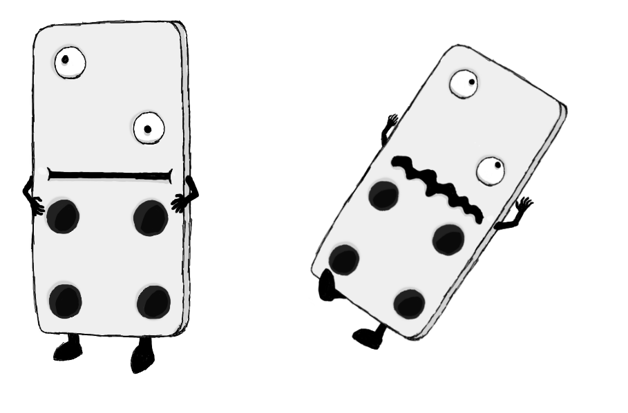

**Brief Synopsis**

The Domino is a tall bulky enemy if attacked from the ground using weapons like the sword or the scythe it will take more than a few hits to kill. However, on hitting it using an **aerial** attack or using the **Shield** charge it will force this enemy to lose balance and topple over, dying instantly. As the name and action implies this enemy is based off a Domino. The Domino act more like an obstacle then an enemy and as such has no attacks, however if needed could shuffle slowly side to side to block a player’s movement.

**AI**

There is no path finding on this enemy, instead it is given a region to guard and it will move sideways within this region to block the players movements.

**Variants**

There are no distinct variants, possible colour swaps could be done for instance having a black and white Domino rather then a white and black one as well as changing the numbers shown on the Domino itself. However, unless changed in the future something like this would not affect the enemy’s behaviour and would be purely cosmetic.

**Animations**  
 **Idle:**

* It will stand there not moving much, maybe having its eyes looks around randomly but nothing particularly special.

**Shuffling:**

* It will wobble slightly onto its legs and move to the side.

**Death:**

* It will fall onto its back and then fade out.